Questions about the real world feathers
looking with fresh eyes, a question about how or why things are how they are
WHY DO I FEEL I SHOULD CONSTANTLY HAVE NEW CLOTHES?
WHY AREN’T ALL GARMENTS COMPOSTABLE?

Precedents: real-world examples shells
a contemporary or historical example of a better way of living with our clothes
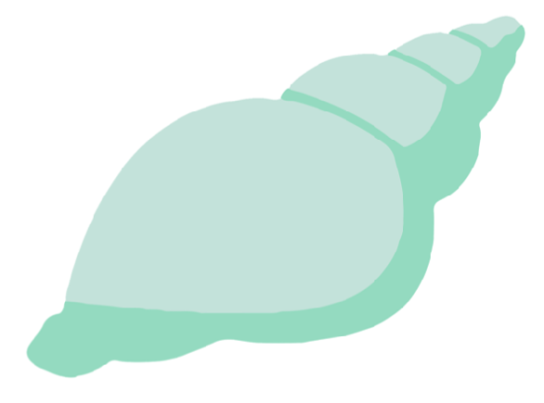
PEER-TO-PEER CONNECTIONS IN THE EARLY DAYS OF EBAY
RAINWATER: NATURAL FABRIC SOFTENER

Ideas for action in the real world leaves
something you want to see happen; be guided by desire, not practicality
NURTURE CRITICAL THINKING
IMPROVE MY EMBROIDERY SKILLS

- For all three themes, you can think personally or collectively
- Your contribution might connect directly to the fictional World, or not
- Capture your idea as concisely as possible
- Use marker pen so your text stands out
- Write on top of the template (not on the back)

